Developer User Guide

The Proteome Browser

Confidential and Proprietary Information
This document contains information that is proprietary to Monash University. Transmittal, receipt, or possession of this document does not express license, or imply rights to use, sell, design, manufacture, or to have manufactured, any product, concept, or service from this information. No reproduction, publication, or disclosure of this information, in whole or in part, electronic or otherwise, shall be made without prior written authorization of an officer of Monash University
Authorized transfer of this document from the custody and control of Monash University constitutes a loan for limited purpose(s), and this document must be returned to Monash University upon request, and in all events, upon completion of the purpose(s) of the loan.

Document Change Log

Prepared By | Module | Date | Version
Simon Yu |  | 31/01/2013 | V1

Revisions

Modified By | Reason | Date | Version

Table of Contents

1. Introduction 4
1.1. Purpose 4
1.2. Audience 4
2. How to develop 4
2.1. Software Versions 4
2.2. Project Structure 5
2.3. SVN Checkout 5
2.4. Ant Build XML Outline 6
2.5. Configuration Files 7
3. How to deploy 8
3.1. Change Configuration Properties 8
3.2. Generate a war 8
3.3. Install Tomcat Web Server 8
3.4. Deploy a War 9
3.5. Check the deployment 9

Introduction

Purpose
This document is intended to address developing, installation and configuration details of the actual implementations.

This document will be updated and refined based on changing implementations.

Audience
The intended audiences for this document are stakeholders, the project development teams, technical architects and system administrators.

How to develop

Software Versions
- Java SE 1.6x
- Tomcat6.x or above
- Java Developing IDEA – IntelliJ 11.x or Eclipse 3.2.x
- Apache Ant1.8 or above
- Struts2.3.8 or above
- Spring 3.1x or above
- Hibernate 4.1 or above
- Jquery 1.7
- SVN 1.6
- PostgreSQL 9.0 or above

Project Structure
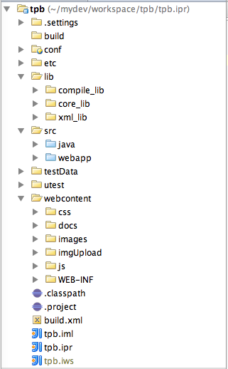

SVN Checkout
SVN repository is available at http://code.google.com/p/hupohpp/source/checkout.

Use the following commands to anonymously check out the latest project source code:

svn checkout http://hupohpp.googlecode.com/svn/trunk/ tpb

Ant Build XML Outline

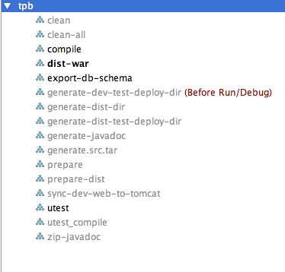

The Ant default target is dist-war that will create a war archive file. The Ant targets are explained as the followings:

Ant Targets | Comments
clean | cleans up the compiled classes, deletes the build directory
clean-all | cleans up all (delete build directory, deploy and dist directory)
compile | compiles the java source code
dist-war | packages a war file
export-db-schema | exports the database schema into a file
generate-dev-test-deploy-dir | generates the developing deploy context directory
generate-dist-dir | generates a distribution directory
generate-dist-test-deploy-dir | generates the distribution deploy testing directory
generate-javadoc | generates the Java API documentations
generate-src-tar | generates the project source tar archive file
prepare | prepares the build directory
prepare-dist | prepares the distribution
sync-dev-web-to-tomcat | synchronizes the dev web source to tomcat
utest | junit testing
utest_compile | compiles the junit testing java source code
Zip-javadoc | archive the java docs

Configuration Files
The configuration files are location in the /conf directory:

- merc.properties – The main system configuration file, which will be loaded by Spring during the system startup. For more details, please see the merc.properties file.
- jdbc.properties – The system database configuration file, which will be loaded by Spring during the system startup. For more details, please see the jdbc.properties file.
- mail.properties – The system mail server configuration file, which will be loaded by Spring during the system startup. For more details, please see the mail.properites file.
- rifcs.properties – The ANDS rifcs public registration file, which will be loaded by the Spring during the system startup. For more details, please see the rifcs.properties file.
- cron.properties – The system cron jobs setting file, which defines the scheduled data importing time and rifcs public registration time. For more details, please see the cron.properties file.
- applictionContext.xml – The system Spring configuration, which will be loaded by the web.xml during the system startup. For more details, please see the applicationContext.xml file.
- struts.xml – The Struts2 configuration file, which defines each action.
- validator.xml – The Struts2 validation configuration file.
- hibernate.cfg.xml – The hibernate domain objects configuration file, which defines the domain objects and how to map these domain objects into database table using hibernate-annotations.
- messageResource.properties - The Struts2 message resource file.
- log4j.properties - The Log4j configuration file.
- web.xml – The web configuration file.
- tpbinitDb.xml – it defines the TPB predefined data type and the evidence color levels.

How to deploy

Change Configuration Properties
Configure the all properties in the configuration files with the proper values including creating a database called tpb.

Generate a war
Use this commands to generate a distribution war archive file, or use the IDEA to run the Ant dist-war target:

- cd tpb
- ant dist-war

The Ant dist-war target will create a war file under tpb/dist/war/tpb.war directory.

Install Tomcat Web Server
Go to the Apache Tomcat website at http://tomcat.apache.org/download-70.cgi, download the Tomcat 7. Untar the tomcat server into /srv/webserver/tomcat directory

Deploy a War
Drop the war file from tpb/dist/war/tpb.war directory, and put it into Tomcat webapps directory. And starup Tomcat server:

/srv/webserver/tomcat/bin/startup.sh

Check the deployment
Open your favorite browser – Firefox or Chrome. And type http://localhost:8080/tpb, it will show the TPB home page.

